RESTAURANT BILL GENERATOR.

**1. Introduction:-**

The aim of our project is to develop a system that is built to partially computerize the work performed in the Restaurant like generating bill of customer, record the customer order and generate the bill.

We have designed & implemented restaurant bill generator which calculates the total amount of bill along with taxes & displays a printable format of the bill. We designed the GUI (Graphical User Interface) with the help of Tkinter module & the prices related to the menu items are stored in a database & they are retrieved while calculating the total.

**1.1. Objectives:-**

1. To build a restaurant bill generator using the Tkinter module.
2. Menu items and their prices should be stored in a database.
3. The restaurant bill generator system is used to overcome the problem which they are facing currently in restaurant sector & making of the manual system to a complete customized & computerized system.

**2. Design:**

**2.1. Tkinter:**

Tkinter is a Python binding to the Tk GUI toolkit. It is the standard Python interface to the Tk GUI toolkit, and is Python's de facto standard GUI. Tkinter is included with the standard Microsoft Windows and Mac OS X install of Python. The name Tkinter comes from the **Tk interface**. Python has a huge number of GUI frameworks (or toolkits) available for it, from Tkinter (traditionally bundled with Python, using Tk) to a number of other cross-platform solutions, as well as bindings to platform-specific (also known as "native") technologies.

**2.2. PyMySQL:**

MySQL is an open-source Relational Database Management System (RDBMS).Despite of its powerful features, MySQL is simple to set up and easy to use. MySQL is a central component of the LAMP open-source web application software stack (and other "AMP" stacks). LAMP is an acronym for "Linux, Apache, MySQL, & Perl/PHP/Python". Major features as available in MySQL are: cross-platform support, cursors, triggers, Unicode support, etc

**2.3. Multi List Box:**

MultiListBox is a listbox that allows more than one item to be inserted. A list is a way to store many values. Multilistbox is easy to use. A multi list box is a list of choices that looks like a scrollable list instead of a typical list box. User can insert an entry in the list. Depending on how you design the multi list box.

**2.4 Time:**

This module provides a number of functions to deal with dates and the time within a day. It’s a thin layer on top of the C runtime library. A given date and time can either be represented as a floating point value (the number of seconds since a reference date, usually April 1st, 2018), or as a time tuple. The method **localtime()** is similar to gmtime() but it converts number of seconds to local time. If secs is not provided or none, the current time as returned by time() is used.

**3. Execution:-**

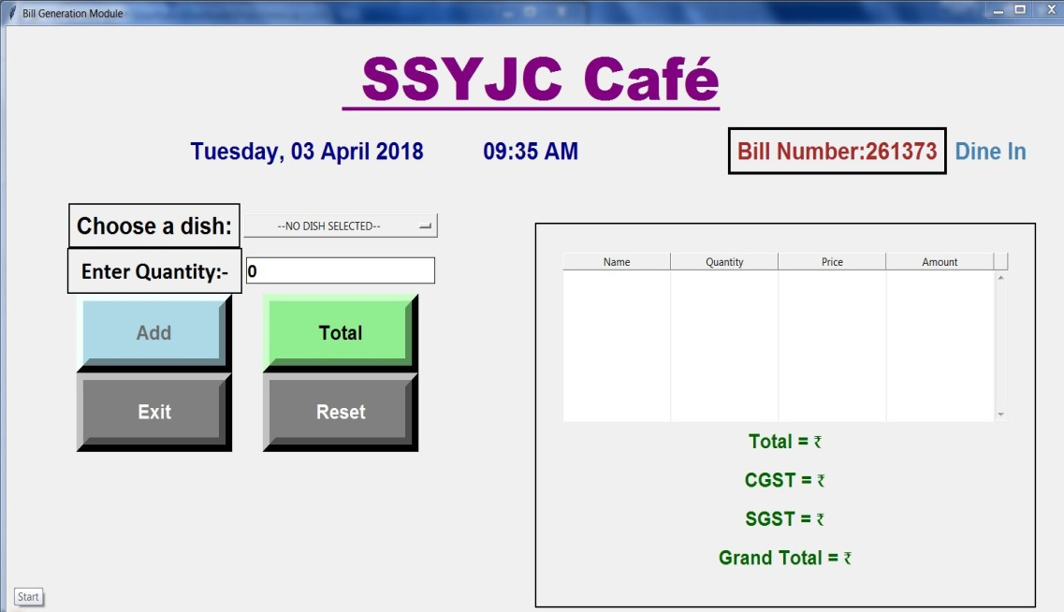

Fig 3.1- First Frame of Interface

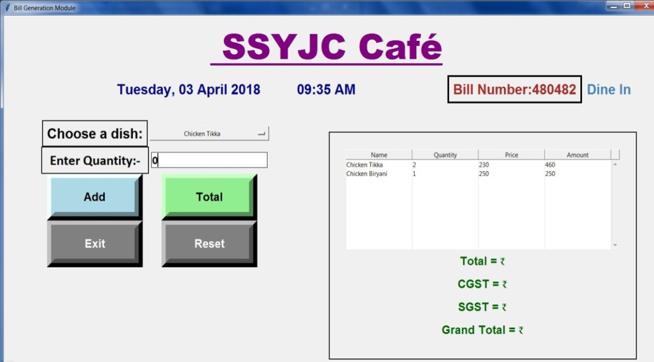

Fig 3.2-Insert and add the number of quanity

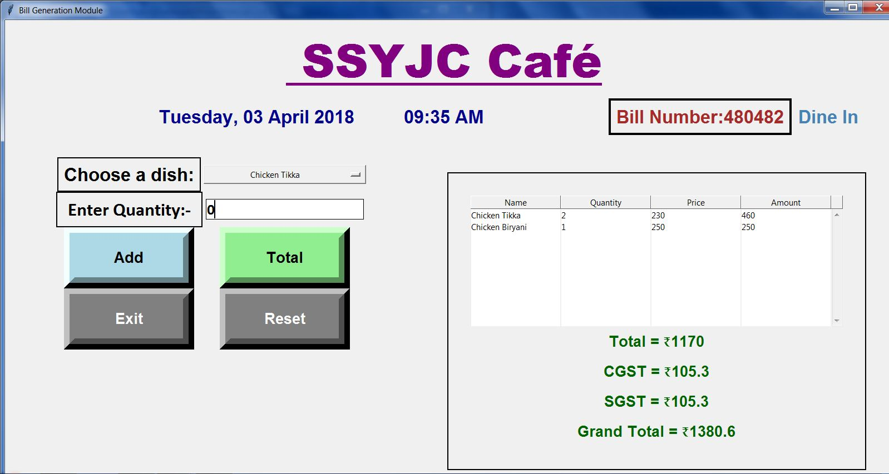

Fig 3.3- Generate the bill along the proper tax

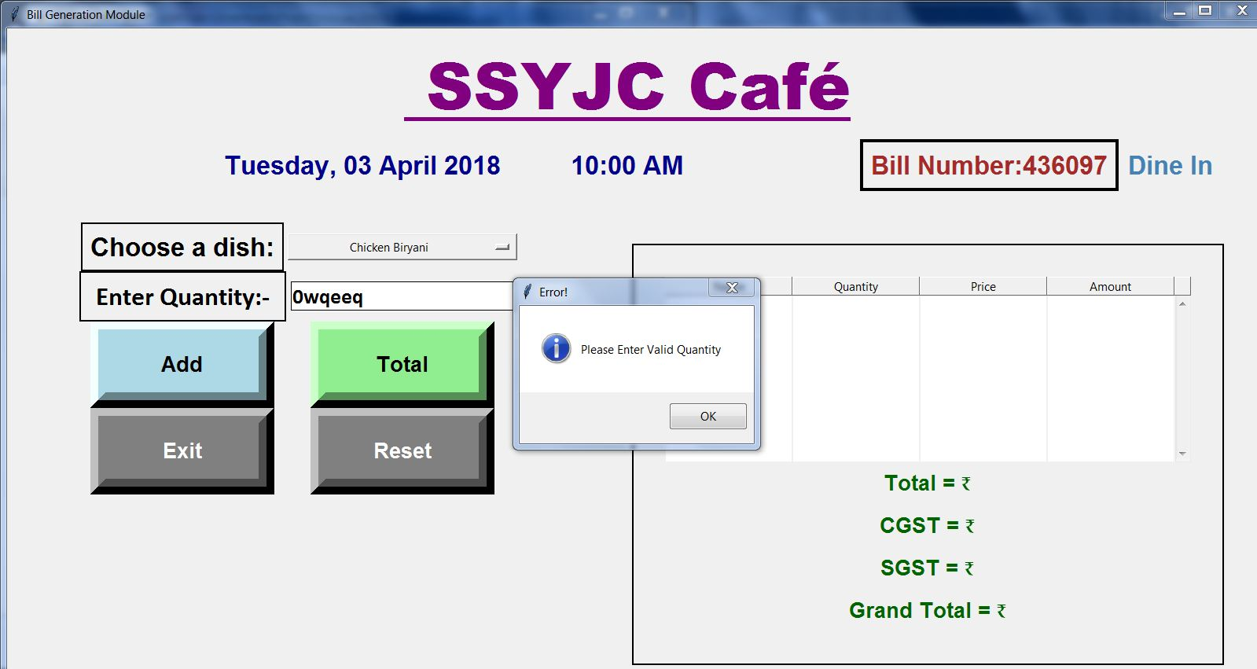

Fig 3.4- Error frame

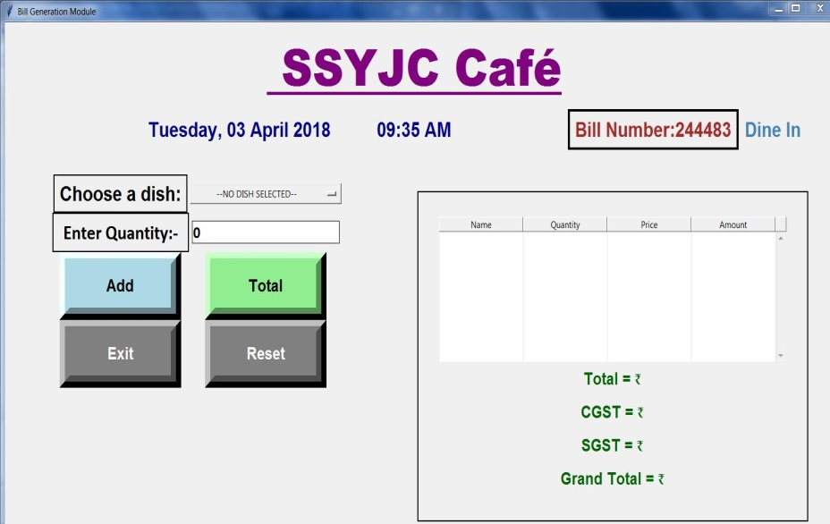

**Future Scope:-**

Current scope of the project is to manage the data in a centralized manner as database is used in it. As being a GUI application this will help the end user to easily manage the software and keep records. This software can also be loaded modules such as Monthly Analysis on the products so as to get the data of the products frequently used by the customers. Also functionality such as generation of the bill can be added for physically storing the records. This can be expanded not for only restaurant management but also various fields where need of billing is required.

**GitHub Link:** https://github.com/saad0428/Restraunt-Bill-Manament/tree/master/

Fig 3.5- Reset Frame